**PATFIN NURSERY AND PRIMARY SCHOOL, AKESAN, LAGOS STATE.**

**FIRST TERM EXAMINATION [ 2019 / 2020 ]**

**CLASS : NURSERY 1**

**NAME : ___________________________________________ SUBJECT : BASIC SCIENCE**

**INSTRUCTION : ANSWER ALL QUESTIONS DURATION : 1 HOUR**

1. ____________ are things that can grow . [a] Human Right [b] Living things
2. Pawpaw and Banana plants are examples of a plant. [ Yes || No ]
3. Flowers can be used for decoration. [ True || False ]
4. Goats and Hens are an example of Domestic Animals. [ Yes || No ]
5. A fish is a water animal. [ True || False]

**PATFIN NURSERY AND PRIMARY SCHOOL, AKESAN, LAGOS STATE.**

**FIRST TERM EXAMINATION [ 2019 / 2020 ]**

**CLASS : NURSERY 1**

**NAME : ___________________________________________ SUBJECT : SOCIAL HABITS**

**INSTRUCTION : ANSWER ALL QUESTIONS DURATION : 1 HOUR**

1. A family is a group of people related by blood. [ True || False]
2. The Governor of Lagos State is ______________________________________.
3. Blind people can’t see. [ True || False]
4. The police protect us from robbers and thieves. [ True || False]
5. Sharing things with our friends is a good habit. [ True || False]

**PATFIN NURSERY AND PRIMARY SCHOOL, AKESAN, LAGOS STATE.**

**FIRST TERM EXAMINATION [ 2019 / 2020 ]**

**CLASS : NURSERY 1**

**NAME : ___________________________________________ SUBJECT : HEALTH HABIT**

**INSTRUCTION : ANSWER ALL QUESTIONS DURATION : 1 HOUR**

1. The teeth can be found in the mouth . [ Yes || No ]
2. We eat and talk with our nose. [ True || False ]
3. The ___________ is a place where we urinate . [a] Gutter [b] Toilet
4. We use our towel to dry our body after bathing. [ Yes || No ]
5. Eating in the toilet is a bad habit . [ True || False]

**PATFIN NURSERY AND PRIMARY SCHOOL, AKESAN, LAGOS STATE.**

**FIRST TERM EXAMINATION [ 2019 / 2020 ]**

**CLASS : NURSERY 1**

**NAME : ___________________________________________ SUBJECT : MORAL INSTRUCTION**

**INSTRUCTION : ANSWER ALL QUESTIONS DURATION : 1 HOUR**

1. We must obey our parents. [ True || False ]
2. We should be kind to people . [ Yes || No ]
3. Should we collect things from strangers ? [ Yes || No ]
4. _________________ is a bad habit . [a] Eating [b] Stealing
5. It is against the school rules to fight in the school. [ Yes || No ]

**PATFIN NURSERY AND PRIMARY SCHOOL, AKESAN, LAGOS STATE.**

**FIRST TERM EXAMINATION [ 2019 / 2020 ]**

**CLASS : NURSERY 1**

**NAME : ___________________________________________ SUBJECT : K . O . W**

**INSTRUCTION : ANSWER ALL QUESTIONS DURATION : 1 HOUR**

1. ___________ is a state ? [a] Akesan [b] Lagos
2. Domestic animals are animals that live around us at home. [ Yes || No ]
3. Lions and Tigers are examples of wild animals . [ True || False ]
4. We must wash our hands before and after eating . [ Yes || No ]
5. The young one of a Dog is called a Puppy. [ True || False ]

**PATFIN NURSERY AND PRIMARY SCHOOL, AKESAN, LAGOS STATE.**

**FIRST TERM EXAMINATION [ 2019 / 2020 ]**

**CLASS : NURSERY 1**

**NAME : ___________________________________________ SUBJECT : C . R . S**

**INSTRUCTION : ANSWER ALL QUESTIONS DURATION : 1 HOUR**

1. David killed Goliath [ True || False ]
2. ______________ created the Heaven and the Earth. [a] Adam [b] God
3. We are taught the bible in the church. [ Yes || No ]
4. Adam and Eve lived in the garden of Eden. [ True || False ]
5. Abel brought the very best gift to God. [ Yes || No ]

**PATFIN NURSERY AND PRIMARY SCHOOL, AKESAN, LAGOS STATE.**

**FIRST TERM EXAMINATION [ 2019 / 2020 ]**

**CLASS : NURSERY 1**

**NAME : ___________________________________________ SUBJECT : COMPUTER**

**INSTRUCTION : ANSWER ALL QUESTIONS DURATION : 1 HOUR**

1. ____________ is an electronic that accept and stores data. [a]Computer [b] Mouse
2. Fans and Radios are examples of computer related devices. [ Yes || No ]
3. The system unit is a part of a computer. [ True || False ]
4. Television is not a part of a computer. [ Yes || No ]
5. A keyboard is used to type letters into the computer. [ True || False ]

**PATFIN NURSERY AND PRIMARY SCHOOL, AKESAN, LAGOS STATE.**

**FIRST TERM EXAMINATION [ 2019 / 2020 ]**

**CLASS : NURSERY 1**

**NAME : ___________________________________________ SUBJECT : RHYMES**

**INSTRUCTION : RECITE ALL RHYMES DURATION : 1 HOUR**

1. I’m a little tea pot.
2. Little Bo Peep
3. Butterfly , Butterfly
4. Lavenders Blue
5. Piggy on the railway

**PATFIN NURSERY AND PRIMARY SCHOOL, AKESAN, LAGOS STATE.**

**FIRST TERM EXAMINATION [ 2019 / 2020 ]**

**CLASS : NURSERY 1 ( GOLD )**

**NAME : ___________________________________________ SUBJECT : NUMBER WORK**

**INSTRUCTION :ANSWER ALL QUESTIONS DURATION : 1 HOUR**

1. Count and write numbers 0 – 100

|  |  |  |  |  |  |  |  |  |  |  |
| --- | --- | --- | --- | --- | --- | --- | --- | --- | --- | --- |
|  |  |  |  |  |  |  |  |  |  |  |
|  |  |  |  |  |  |  |  |  |  |  |
|  |  |  |  |  |  |  |  |  |  |  |
|  |  |  |  |  |  |  |  |  |  |  |
|  |  |  |  |  |  |  |  |  |  |  |
|  |  |  |  |  |  |  |  |  |  |  |
|  |  |  |  |  |  |  |  |  |  |  |
|  |  |  |  |  |  |  |  |  |  |  |
|  |  |  |  |  |  |  |  |  |  |  |
|  |  |  |  |  |  |  |  |  |  |  |

1. Fill in the gaps. *50 – 100*

50 _____ 52 ________ 54 _______ 56 _______ 58 ___________ 60 ______ 62 ______ 64 ______ 66 ______ 68 ______ **70** ______ 72 ______ 74 ______ 76 ______ 78 ______ 80 ______ 82 ______ 84 ______ 86 ______ 88 ______ 90 ______ 92 ______ 94 ______ 96 ______ 98 ______ 100 .

1. Count ***30 – 0*** backwards

|  |  |  |  |  |  |  |  |  |  |
| --- | --- | --- | --- | --- | --- | --- | --- | --- | --- |
|  |  |  |  |  |  |  |  |  |  |
|  |  |  |  |  |  |  |  |  |  |
|  |  |  |  |  |  |  |  |  |  |

1. Write in words ;

1 = __________

2 = ______________

3 = _________________

4 = ___________________

1. Simple Additions
2. 5 + 2 =

00000 00

1. 2 + 2 =

00 00

1. 4 + 1 =
2. 0

**PATFIN NURSERY AND PRIMARY SCHOOL, AKESAN, LAGOS STATE.**

**FIRST TERM EXAMINATION [ 2019 / 2020 ]**

**CLASS : NURSERY 1 ( GOLD )**

**NAME : ___________________________________________ SUBJECT : LETTER WORK**

**INSTRUCTION :ANSWER ALL QUESTIONS DURATION : 1 HOUR**

1. Blending two(2) letter words with sound ***‘a’*** .
2. a n a t a s

_________ __________ __________

1. Blending two letter words with sound ***‘u’*** .
2. u p u s

__________ __________

1. Read and copy these two letter words with the ‘i’ sound

It is in

_____________

Is it in

_____________

In it is

_____________

1. Read and copy two(2) letter words with ‘a’ sound .
2. i am on

_____________

1. am I on

_______________

1. on I am

_______________

1. Write out five(5) two letter words.
2. __________
3. ___________
4. _____________
5. _______________
6. _________________

**PATFIN NURSERY AND PRIMARY SCHOOL, AKESAN, LAGOS STATE.**

**FIRST TERM EXAMINATION [ 2019 / 2020 ]**

**CLASS : NURSERY 1 ( SILVER )**

**NAME : ___________________________________________ SUBJECT : NUMBER WORK**

**INSTRUCTION :ANSWER ALL QUESTIONS DURATION : 1 HOUR**

1. Count and write numbers **0 - 50**

|  |  |  |  |  |  |  |  |  |  |
| --- | --- | --- | --- | --- | --- | --- | --- | --- | --- |
|  |  |  |  |  |  |  |  |  |  |
|  |  |  |  |  |  |  |  |  |  |
|  |  |  |  |  |  |  |  |  |  |
|  |  |  |  |  |  |  |  |  |  |
|  |  |  |  |  |  |  |  |  |  |

1. Count and match

000 10

0000000 5

00000 2

00 7

0000000000 3

1. Fill in the gaps. [ Numbers 51 - 100 ]

51 _______ 53 _____ 55 _____ 57 _____ 59 _____ 61 _____ 63 ____ 65 ____ 67 ____ 69 ____ 71 _____ 73 ______ 75 ______ 77 ____ 79 _____ 81 _____ 83 ____ 85 _____ 87 ___ 89 ____ 91 ____ 93 ______ 95 ____ 97 _____ 99 _____.

1. Underline the biggest object





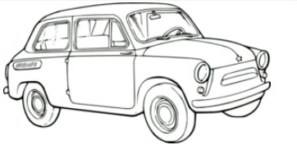







1. Write out five(5) odd numbers
2. __________
3. ___________
4. ______________
5. ________________
6. __________________

**PATFIN NURSERY AND PRIMARY SCHOOL, AKESAN, LAGOS STATE.**

**FIRST TERM EXAMINATION [ 2019 / 2020 ]**

**CLASS : NURSERY 1 ( SILVER )**

**NAME : ___________________________________________ SUBJECT : LETTER WORK**

**INSTRUCTION :ANSWER ALL QUESTIONS DURATION : 1 HOUR**

1. Read and write small letters ***a – I***

|  |  |  |  |  |  |  |  |  |  |
| --- | --- | --- | --- | --- | --- | --- | --- | --- | --- |
|  |  |  |  |  |  |  |  |  |  |

1. Associating pictures with letters.

e



d



c

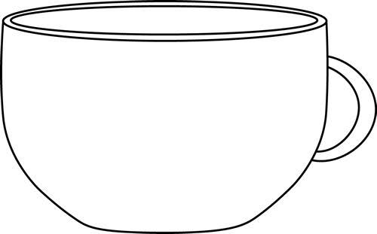

b

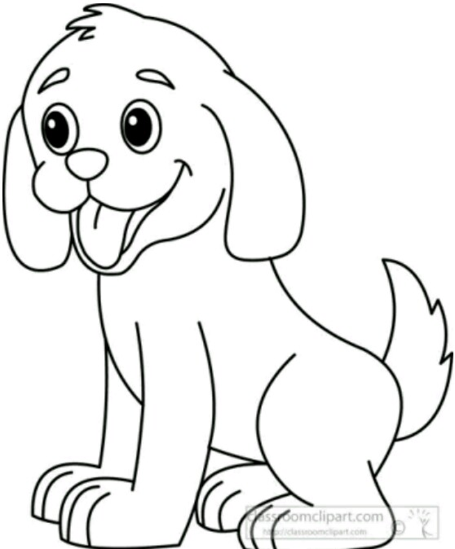

a

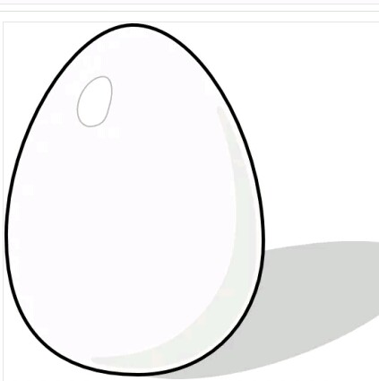

1. Fill in the missing letters .

_______ b _______ d ______ f _______ g _____ i.

1. Color these shapes with primary colors .
2. Match same letters together

a I

b h

c g

d f

e e

f d

g c

h b

I a